 Location Groups and Pages

Investigation Exercise

1. Navigate to the Loss Details screen for an Auto claim. Identify the name of the PCF file that contains the currently visible element. (Choose the best shortcut depending on the information you need - the Info Page (Alt-Shift-I), the Widget Inspector (Alt-Shift-W), or Studio (Alt-Shift-E)).

What file contains the...

a) Tab bar (HINT: It starts with "Tab") ______________
b) "Second-level" location group (which includes the side bar) ______________
c) "Third-level" location group (which renders as screen links) ______________
d) Page ______________
e) Screen ______________
f) Detail view ______________

Answer the following questions about the PCF file that contains the Claim tab's location group.

2. How many entry points does the location group have?

3. What is the name of the file that stores the location group's info bar? What sort of widget is the first (left-most) widget in the info bar? Is this widget always displayed? What about the second widget?

4. What is the name of the file that stores the location group's menu actions? What is the name of the first menu item in this file which is stored directly in this file (and not referenced by a Menu Item Set Ref) and which does something when clicked (as opposed to being a non-clickable label)?

5. In the file containing the Claim tab's location group, there is a location ref named "Subrogation". The location ref has no visible condition, and yet it does not display when you view the Ray Newton auto claim. Why?

Configuration Exercise

Configure ClaimCenter to meet the following customer requirement from Acme Insurance.

In the base application's data model, officials (police officers, fireman, coroners, and so on) are stored in the Official entity. All other people associated to the claim (insured, claimants, vendors, witnesses) are stored in the Contact entity. As a result, the list of officials associated to a claim appears on the Loss Details screen.

Adjusters at Acme Insurance find this confusing. They think of officials as part of the "parties involved" in a claim. Therefore, they have requested to have the Officials list moved to be a screen link of the Parties Involved menu link.

6. Modify the Claim location group so that:
- There is a new screen link off of the Parties Involved menu link between Contacts and Users. The new screen link is labeled "Officials".
- The screen link points to a screen which is labeled "Officials" in the title bar. When the screen is displayed, it is rendered in edit mode. The screen also has Edit / Update / Cancel buttons.
- The screen contains the Officials list view (which currently appears on the Loss Details screen). The list view has a toolbar with Add / Remove buttons.
- For the time being, the Officials list should remain on the Loss Details screen as well.

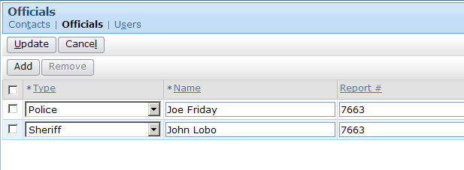

7. The ClaimCenter implementation team has provided additional notes:
- The recommended approach is to build the page from scratch. (In general, there are two approaches to meet a requirement like this: copy and modify an existing page, or build a new page from scratch. Copying and modifying an existing page is a viable option when you fully understand the functionality of the page you are copying. Many of the existing pages in the base application have functionality which may not be immediately apparent (such as permissions around who can view or edit the page). Therefore, for this lab, you are encouraged to create the new page from scratch. Start first by building the page element, then refer to your new page from the parent location group.

Test Case

When you have completed your configuration, run the following test case:

8. Navigate to a claim. Verify that the Parties Involved menu link now includes an additional subtab which displays the Officials list.

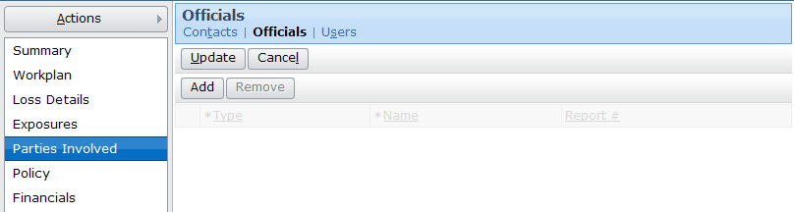

9. Add one official to the list on the new Officials page and one official to the list on the Loss Details page. Verify that both officials display in both lists.

